HEART SAFE CPD+
Terms and Conditions of Membership
Heart Safe Consultancy & Training Ltd
Cirencester, Gloucestershire, United Kingdom
Effective date: 24th AUGUST 2026
Version: Version 1.
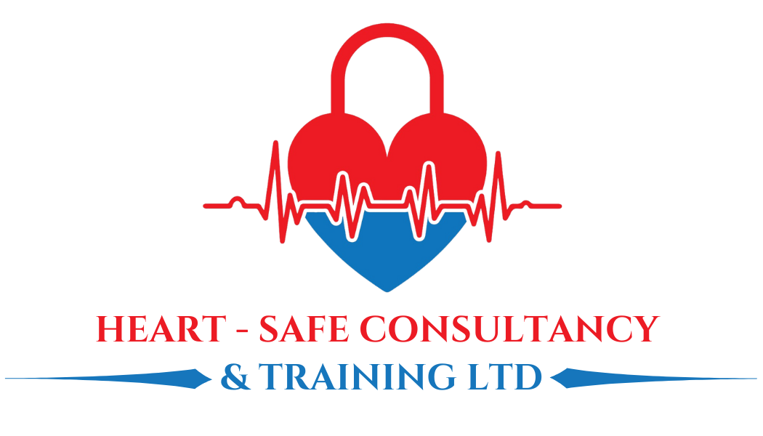

1. About These Terms
These Terms and Conditions ("Terms") govern your membership of Heart Safe CPD+ (the "Programme"), operated by Heart Safe Consultancy & Training Ltd ("Heart Safe", "we", "us", "our"), a company based in Cirencester, Gloucestershire, United Kingdom.
By joining Heart Safe CPD+, you ("Member", "you", "your") agree to be bound by these Terms. Please read them carefully before signing up. If you do not agree to these Terms, you should not join the Programme.
These Terms apply to individual healthcare professionals joining in a personal capacity. Organisations wishing to purchase membership on behalf of staff should contact us directly for separate terms.

2. Definitions
- "Membership Year" means each consecutive 12-month period of your membership, beginning on your join date.
- "Tier" means the level of membership you have selected: Bronze, Silver, Gold or Platinum, as further described in clause 4.
- "Education Credit" means the annual face-to-face course credit included with your Tier, as described in clause 7.
- "Qualifying Period" means the four-month period of continuous membership required before your Education Credit becomes available to use, as described in clause 7.
- "Eligible Course" means a Heart Safe course designated as redeemable against the Education Credit for your Tier, as confirmed at the time of booking.

3. The Programme
Heart Safe CPD+ is a monthly membership pre-pay programme providing ongoing clinical education, comprising:
- Live monthly webinars and case-based discussions;
- Virtual clinical skills teaching sessions;
- Access to a professional discussion community;
- CPD resources and downloadable materials;
- An annual Education Credit redeemable against eligible face-to-face Heart Safe courses (see clause 7).
The specific content, format and frequency of online sessions may vary from time to time. We will give reasonable notice of any material reduction in the online programme.

4. Membership Tiers and Fees
Heart Safe CPD+ is available in four tiers. Current fees (exclusive of VAT, charged monthly) are:
Tier | Monthly Fee (+VAT) | Annual Education Credit | Description
Bronze | £49 | £250 | Essential Clinical Education
Silver | £99 | £500 | Advanced Clinical Education
Gold | £129 | £800 | Professional Clinical Education
Platinum | £229 | £1,200 | Elite Clinical Education

We reserve the right to change membership fees. Where we do so, we will give you at least 30 days' written notice before any change takes effect. Changes will not apply to a Membership Year that has already begun.

5. Payment Terms
Membership fees are collected monthly in advance by continuous payment authority. By joining, you authorise Heart Safe to take recurring monthly payments for the duration of your membership.
If a payment fails, we will attempt to notify you and may make further attempts to collect payment. We reserve the right to suspend access to the Programme, including your Education Credit, if payment remains outstanding for more than 14 days.
All fees are shown inclusive of VAT. VAT will be included at the applicable rate at the time of payment.

6. Minimum Term and Cancellation
Heart Safe CPD+ membership requires a minimum commitment of 12 months ("Minimum Term"), payable monthly. By joining, you agree to pay the monthly fee for the full duration of the Minimum Term, even if you cancel or stop using the Programme before it ends, except as set out below.
Cooling-off period
If you join online or by other distance means as a consumer, you have a statutory right to cancel within 14 days of joining without giving a reason, under the Consumer Contracts (Information, Cancellation and Additional Charges) Regulations 2013. If you cancel within this period, you will receive a full refund of any fees paid, less a reasonable amount for any part of the Programme you have already used or any administration charges incurred by Heart safe (for example, a webinar attended), if you asked us to begin providing the Programme before the cooling-off period ended.
Cancellation after the cooling-off period
After the 14-day cooling-off period, you may give notice to cancel your recurring payment at any time, but you will remain liable for the monthly fees for the remainder of the 12-month Minimum Term, unless we agree otherwise in writing or clause 15 (Termination by Heart Safe) applies.
Renewal
At the end of your Minimum Term, your membership will automatically continue on a rolling monthly basis unless you give at least 30 days' written notice to cancel.

7. Your Face-to-Face Education Credit
Each Tier includes an annual Education Credit, as set out in the table at clause 4, which can be used towards the cost of an Eligible Course. Each tiers eligible courses are set out on the respective webpage associated with each tier on our website www.heart-safe.co.uk
When you can use it
Your Education Credit becomes available after you have held continuous, paid membership for four months (the Qualifying Period). It cannot be used, reserved, or part-claimed before the Qualifying Period has been completed.
How it works
- You are entitled to one Full Education Credit per Membership Year – this may however be split over multiple courses – up to the value of the full course credit..
- The Education Credit can be applied towards the cost of any Eligible Course up to its stated value. If you choose a course priced higher than your Education Credit, you may use your credit towards the cost and pay the difference.
- Your Education Credit is personal to you and cannot be transferred, sold, or gifted to another person.
- Your Education Credit has no cash value and cannot be exchanged for a cash payment or refund.
- You must remain an active, paid-up Member at the time you attend the course for which you are using your Education Credit.
If you don't use it
If you do not use your Education Credit within the Membership Year in which it was earned, it will roll over for use within the following Membership Year only. Any Education Credit not used by the end of that following year will expire and cannot be carried forward further or exchanged for any other benefit.

8. Changing Your Tier
You may upgrade your Tier at any time. Where you upgrade:
- The online benefits of your new, higher Tier (webinars, virtual skills sessions, resources and community access) will apply immediately; and
- Your new, higher-value Education Credit will apply from your next annual renewal date, not immediately. Any Education Credit already earned at your previous Tier is unaffected and remains subject to clause 7.
Downgrades may be requested but will only take effect from your next renewal date, and will not reduce an Education Credit already earned.

9. Using the Online Programme
Webinars, case-based discussions and virtual skills sessions are provided live and may be recorded for members' later viewing. Access to recordings and resources is provided for your personal professional development only and must not be shared outside your membership.
Any CPD certification or accreditation associated with the Programme is provided on the basis described at the time of the relevant activity. It is your responsibility to confirm that any CPD credit meets the requirements of your own professional body or regulator.

10. Community Guidelines
Access to the professional discussion community is a benefit of membership and is provided on the condition that you engage respectfully and professionally with other members and Heart Safe staff and faculty.
We reserve the right to remove content, and to suspend or terminate the membership of any Member, who posts content that is abusive, discloses identifiable patient information, breaches professional or regulatory standards, or is otherwise inappropriate, at our reasonable discretion.

11. Intellectual Property
The name "Heart Safe CPD+", the Heart Safe brand, and all course materials, resources, recordings, templates and content provided as part of the Programme remain the intellectual property of Heart Safe Consultancy & Training Ltd (or its licensors). Membership grants you a personal, non-transferable licence to use these materials for your own professional development. You may not reproduce, distribute, or use them for commercial purposes without our prior express written consent.

12. Data Protection
We process your personal data in accordance with our Privacy Policy and in compliance with the UK General Data Protection Regulation and Data Protection Act 2018. By joining the Programme, you acknowledge that your data will be used to administer your membership, process payments, and communicate with you about the Programme.

13. Limitation of Liability
The Programme is provided for continuing professional development purposes and does not replace, and should not be relied upon as a substitute for, formal accredited course certification, statutory training requirements, or your own professional judgement in clinical practice.
To the fullest extent permitted by law, Heart Safe's liability to you in connection with your membership is limited to the total fees paid by you in the 12 months preceding the event giving rise to the claim. Nothing in these Terms excludes or limits our liability for death or personal injury caused by our negligence, for fraud, or for any other liability that cannot lawfully be excluded or limited.

14. Changes to These Terms
We may update these Terms from time to time, for example to reflect changes in the Programme, our fees, or the law. Where we make material changes, we will give you at least 30 days' notice before they take effect. Continued membership after that date constitutes acceptance of the updated Terms.

15. Termination by Heart Safe
We may suspend or terminate your membership immediately if you breach these Terms materially, including persistent non-payment, misuse of the community, or conduct that breaches applicable professional or regulatory standards. Where we terminate for such reasons, you will remain liable for fees due up to the date of termination, and any unused Education Credit will be forfeited.
We may also terminate the Programme in its entirety, for example if we cease to offer it, by giving you at least 60 days' notice. In these circumstances, we will provide a fair and reasonable resolution in respect of any unused Education Credit, at our discretion and limited only up to the maximum value already paid, where education credits have not already been utilised.

16. General
These Terms, together with our Privacy Policy, constitute the entire agreement between you and Heart Safe in respect of your membership.
If any provision of these Terms is found to be unenforceable, the remaining provisions will continue in full force and effect.
These Terms are governed by the laws of England and Wales, and any disputes will be subject to the exclusive jurisdiction of the courts of England and Wales.

17. Contact Us
If you have any questions about these Terms or your membership, please contact us at:
Heart Safe Consultancy & Training Ltd Cirencester, Chandlers House, 6 Wilkinson Road, Cirencester, Gloucestershire, United Kingdom – info@heart-safe-training.co.uk / 01285 654006

