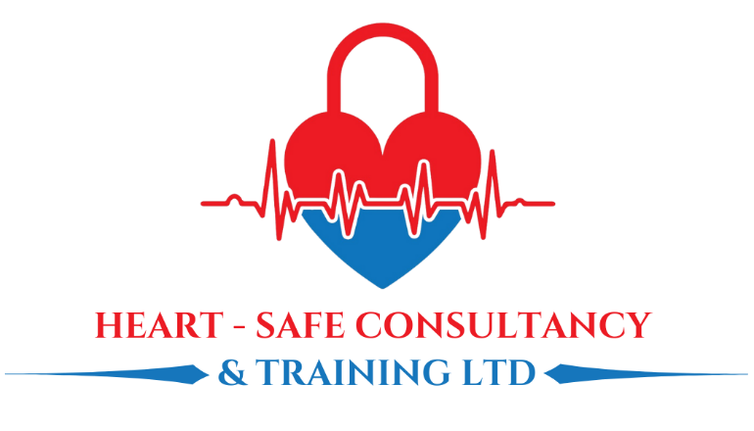
Chandlers House, 6 Wilkinson Road
Cirencester, GL7 1YT
Tel: 01285 654006
Email: info@heart-safe-training.co.uk
ALL SECTIONS MUST BE COMPLETED including attaching an electronic photo. Please email back electronically to
info@Heart-safe-training.co.uk (please do not photograph, scan form or post the form to us, we require an electronic version)

Title | Choose from list | Registration Number: NMC/HCPC/GMC/GDC
D.O. B |  | RCS Number | Click here to enter registration number
First Name: | Click here to enter name. | Place of Work: | Click here to enter place of work
Last Name: |  | Job title:
Postal Address: |  | Speciality:
Post Code: |  | Department: | Click here to enter name.
Gender: | Choose an item. | Allergies:
Email: | Click here to enter email | Allergies:
Mobile: |  | Emergency Contact Name & Number:
Course Applied for: | Choose an item. | Course date required:
Date of application |  | Any special OR accessibility requirements

Please insert a passport sized photo
below by clicking the centre icon



HOW TO PAY:
- Bank transfer: Please include your name as the reference on any payments.
Heart Safe Consultancy & Training Ltd
Sort code 04-00-03 Acc. No. 33596964
- Card payment (please let us know and we can send you a payment link)

X Invoice Employer (please provide ALL the details below)
Employers Name/Address:
Line manager’s email address
Line manager’s Tel No:
Finance email address for invoicing:
Purchase order number:

VAT: Reg. No. 508 1696 80 – please ensure 20% VAT is added to all payments – Many Thanks

Terms and conditions:

Please notify us of any change of address or personal details
- Places will not be confirmed until payment or official purchase order number is received.
- We reserve the right to change the course fee without prior notification.
- Cancellation Policy: Over 30 days = 75% refund on return of course manual,
- Within 30 days = No refund

N.B By submitting this form you agree to terms and conditions.

